Bilkent University
Department of Electrical and Electronics Engineering
EEE 313 Electronic Circuit Design Final Exam
25 May 2012, 15.30 (5 questions, 180 minutes)

- This is a closed book, closed notes exam. No cheat sheet allowed.
- All cell-phones should be completely turned off.
- Use a calculator for numerical computations. Carry at least 3 significant digits. Double check your numerical calculations.
- Be sure to write the units of all numerical results.
- Show all work clearly. Show all the intermediate steps including formulas. Never, just carry out calculations without formulas and explanation.
- Please put your final answer for each part inside a box for easy identification.
Do not give multiple answers, they will not be graded.
- Do not remove the staple from the exam sheets or separate pages of the exam. All extra pages must be stamped to your exam.
- You may leave the exam room when you are done.
However, please do not leave during the last five minutes of the exam.
- At the end of the exam, please stay seated unitl all exam papers are collected.

Useful constants and formulas:
Boltzmann’s constant: 86×10⁻⁶ eV/Kº
Electron charge: 1.6×10⁻¹⁹ Coulombs
Drain currrent equation for n-channel MOSFET:
$I_{D}=K_{n}{(V_{GS}-V_{TN})}^{2}$ for $V_{GS}-V_{TN}≤V_{DS}$
$I_{D}=K_{n}{\left(2{(V}_{GS}-V_{TN}\right)V_{DS}-V_{DS}}^{2})$ for $V_{GS}-V_{TN}≥V_{DS}$

Drain currrent equation for p-channel MOSFET:
$I_{D}=K_{p}{(V_{SG}+V_{TP})}^{2}$ for $V_{SG}+V_{TP}≤V_{SD}$
$I_{D}=K_{p}{\left(2{(V}_{SG}+V_{TP}\right)V_{SD}-V_{SD}}^{2})$ for $V_{SD}+V_{TP}≥V_{SD}$

Forward active current of BJT is given by:
$$I_{C}=I_{S}\left(e^{\frac{V_{BE}}{nV_{t}}}-1\right)$$
Other equations must be deduced by the students.
Please do not write below this line

1. 30 pts.
2. 30 pts.
3. 20 pts.
4. 20 pts.
Total 100 pts.

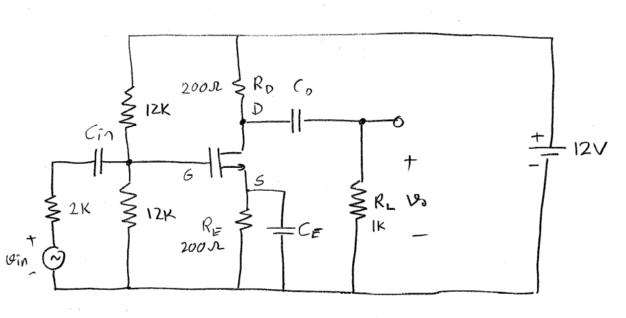
- Question: (30 Pts.) At the circuit given above, the transistor is an n-channel MOSFET with K_{n}=2.5x10⁻³mhos and V_{TN}=2Volts. Answer the following:
  - (9 Pts.) Find the DC bias of the transistor.
  - (9 Pts.) Assuming that the capacitors C_{in}, C_{E} and C_{o} are very large and the drain current is equal to 10mA, find the voltage gain of the amplifier defined as v_{o}/v_{in}.
  - (12 Pts.) The amplifier is to be used to amplify music signals. The BW of the music signal is assumed to between 20Hz and 20kHz. Find limiting values for the capacitors C_{in}, C_{E} and C_{o} seperately for each them in order to put the 3dB-cutoff frequencies to the appropriate frequency assuming that the others are very large each time and the drain current is equal to 10mA.

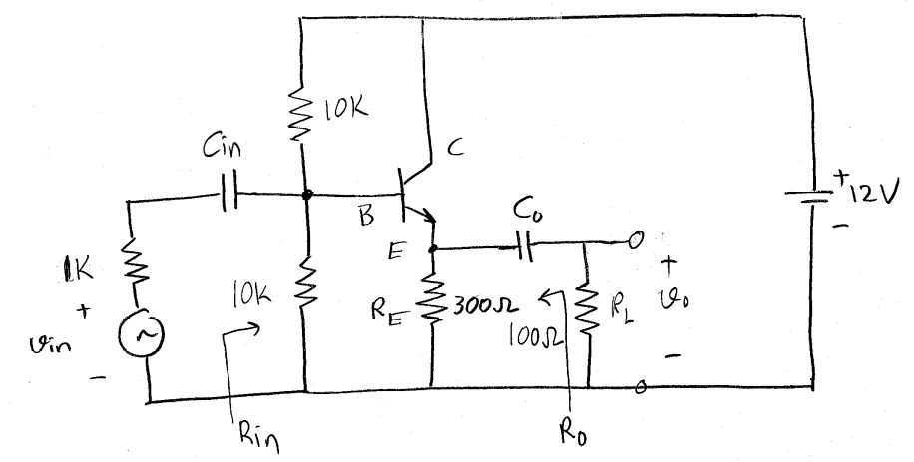

- Question: (30 Pts.) For the circuit given above β=120, V_{CESAT}=0.4Volts and V_{BESAT}=0.7Volts. Answer the following:
  - (6 Pts.) Find the DC bias of the transistor.
  - (7 Pts.) Find the voltage gain of the amplifier defined as v_{o}/v_{in} assuming that the Capacitors C_{in} and C_{o} are very large and the collector current is 15mA.
  - (10 Pts.) Find the input and output resistances as shown at the figures assuming that the collector current is 15mA.
  - (7 Pts.) Find the output peak-to-peak undistorted voltage swing assuming that the collector current is 15mA.

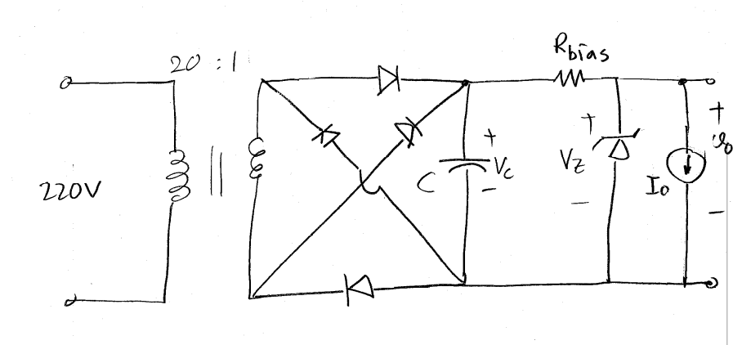
- Question: (20 Pts.) At the circuit given above, V_{γ}=1Volt, V_{z}=7Volts, I_{zmin}=20mA, I_{o}=200mA, the transformer input is 220V_{rms} and 50Hz, the transformer is ideal and r_{o} (the output resistance) of the zener diode is equal to 0. Answer the following:
  - (10 Pts.) Find the minimum value of R_{bias} which will work with 2V_{p-p} ripple voltage,
  - (10 Pts.) Find the approximate value of the capacitance of the capacitor C which will limit the ripple voltage to 2V_{p-p} if the value of R_{bias} were 15Ω and maximum current is drawn from the power supply.

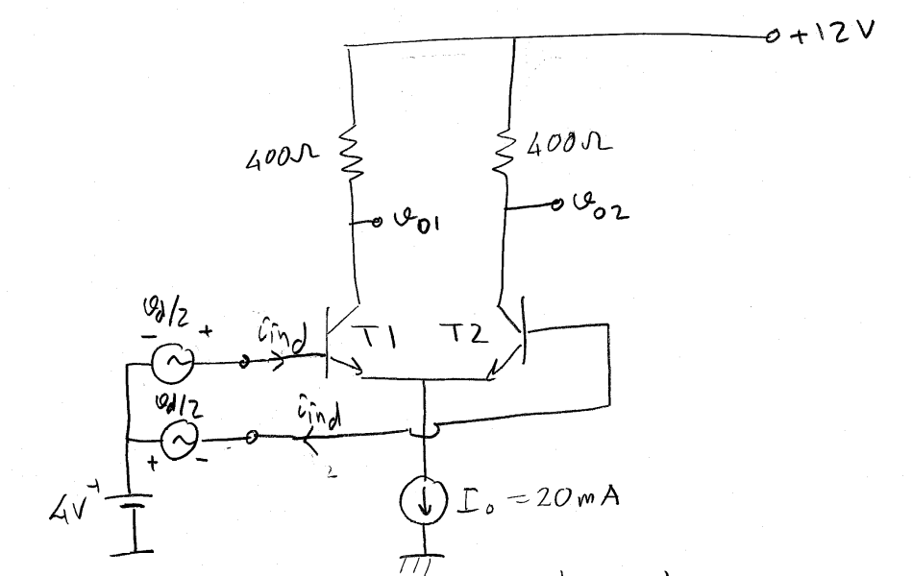
- Question : (20 Pts.) For the circuit given above β=100, V_{CESAT}=0.4Volts and V_{BESAT}=0.7Volts. answer the following:
  - (6 Pts.) Find the states of the transistors and transistor currents assuming v_{d}=0,
  - (7 Pts.) Find the small signal voltage gain defined as (v_{o1}-v_{o2})/v_{d},
  - (7 Pts.) Find the differential input resistance defined as R_{ind}=v_{d}/i_{ind}.

v_{o1}, v_{o2}, v_{d} are AC voltages,
v_{d} is the differential input voltage,
R_{ind} is the differential input resistance,
i_{ind}is the differential input current.

